Name: A.Lakshmi Likitha Course Code: ITA0330
Reg No: 1929472132 Course Name: Mobile Computing
Slot: D

Experiment 2: Mobile Station User Interface Prototype

Aim: To design a mobile station user interface prototype in Figma, considering connectivity and convenience.
Procedure:
- Open Figma and create a new mobile frame.
- Design the home screen with a title and network status.
- Add Wi-Fi, signal, and battery symbols.
- Create buttons for calls, messages, internet, and settings.
- Design additional screens for connectivity, calls, and settings.
- Use Prototype mode to connect the screens through interactive buttons.

Output:
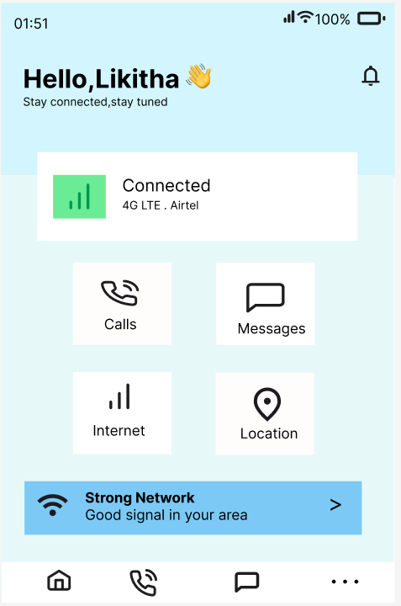


Result: A mobile station UI prototype with connectivity features and convenient navigation was designed successfully.

